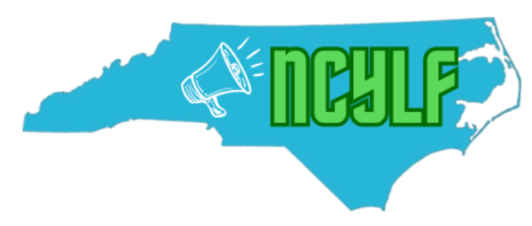
North Carolina Youth Leadership Forum 2024: Volunteer Form
North Carolina State University
July 20th-24th, 2024

About The North Carolina Youth Leadership Forum (NCYLF):

NCYLF helps to foster emerging youth and young adult leaders between 15 and 30 years old, teaching them to advocate for themselves and in their communities. The Youth Leadership Forum is unlike a summer camp in that it focuses its activities on developing leadership and communication skills throughout the week. It’s an opportunity to network,meet other people with varying disabilities, and share your perspectives and experiences with others. Once you graduate from an YLF, you become part of an alumni network of other young leaders across the United States.

The YLF aims to support today’s young people in their transition process. This can include transitioning from high school to college, college to work, moving out of parents home, or any other transition phase that may be taking place.

NCYLF is a fully accessible event, free of charge to all participants. NCYLF provides all requested accommodations, such as personal care attendants, certified nursing assistants, and interpreters. The next generation of disability rights leaders begins with empowering and providing the necessary tools to our young adults. Through fun and engaging activities, NCYLF builds young leaders while enabling them to experience independence and find their voices as advocates.

General info:
Name:

Date of birth:

Age:

Race/ethnicity (optional):

Gender:

Pronouns (optional):

Parent/guardian if under 18:

Phone:

Email:

Address:

County:

Preferred method of contact:

Volunteer roles:
Please check any of the following that you are interested in doing! We will work with you to find the right times on the days you are volunteering.

July 18, 2024 (set up day):
____ Putting staff binders together (hole-punching, putting pages into binder)
____ Setting up staff and delegate welcome bags
____ Cleaning living spaces (wiping down tables and kitchen) and organizing/setting up kitchen
____ Helping carry materials, etc into building
____ Get bathrooms ready (shower chairs, hanging up curtains, etc)
____ *if you have a truck, we need someone to help us move materials from our storage unit!

July 19, 2024 (staff training day):
____ Help setting up for the day
____ Help the Food Coordinator with set up/clean up snacks and meals
____ Help staff get luggage into their rooms
____ Help with cleaning up for the day/set up for check-in day

July 20, 2024 (check-in day, delegates arrive):
____ Photography
____ Welcoming delegates and leading them to check-in table
____ Assisting with checking delegates in
____ Showing delegates their rooms and helping with luggage
____ Helping with parking and directing delegates/parents to the proper places
____ Help the Food Coordinator with set up/clean up snacks and meals

July 21, 2024:
____ Photography
____ Help the Food Coordinator with set up/clean up snacks and meals
____ On standby for any needed assistance

July 22, 2024:
____ Photography
____ Help the Food Coordinator with set up/clean up snacks and meals
____ On standby for any needed assistance

July 23, 2024:
____ Photography
____ Help the Food Coordinator with set up/clean up snacks and meals
____ On standby for any needed assistance

July 24, 2024 (check-out day):
____ Help the Food Coordinator with set up/clean up snacks and meals
____ Assisting with checking delegates out
____ Helping delegates with luggage
____ Laundry
____ Cleaning up/taking everything down
____ *If you have a truck, we need help with transporting materials back to our storage unit!

There are other ways to help with the 2024 YLF outside of the duration of the event such as:
- Helping us find donation opportunities including meals and snacks or monetary donations
- Spreading the word about YLF volunteer opportunities

Are weekends or weekdays better for your availability? Are there any times that will NOT work for you? Any times and/or days that you know of that WILL work for you?
*If you are not currently sure, please write that, and our Program Coordinator will reach out to you when we get closer to the event to discuss availability!

Upon arrival:
Please bring a form of identification (driver’s license, real ID, or passport) to show when you arrive, and check in with a staff member! We will be sending you a packet of more information when YLF gets a bit closer (like parking, where we will be when you arrive, etc).

Please contact our Program Coordinator, Meredith Huml, for any questions! You can reach her at meredith@youthleadnc.org or at 919-213-0175. Please email or text to set up a phone call, email is the best and quickest way to reach us!

