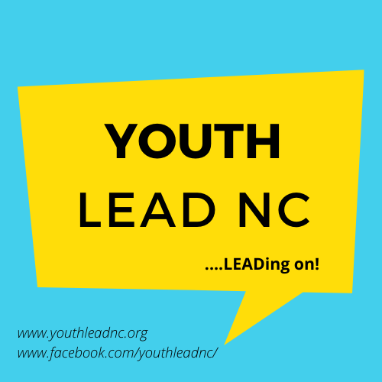
Youth LEAD NC
Board of Directors
Application

A warm welcome from the Board of Directors at Youth LEAD NC!

Hello,

Welcome! You are receiving this application to join the Board of Directors at Youth LEAD NC (LEAD) because you have expressed interest in the position, been recommended by a current member, or been identified as someone who we want to pursue as a potential director on our board.

LEAD is a youth-led organization that was founded by a passionate group of advocates. We hope that you take this opportunity to learn more about our mission and vision to build the next generation of leaders in the Disability Rights Movement.

We are actively seeking potential board members with diverse backgrounds and unique skill sets who are looking to leave their mark on a young nonprofit. Applications are reviewed on a rolling basis and approved by the members of the organization in accordance to LEAD’s bylaws.

If you have any questions or need accommodations to complete this application, please email us at youthleadnc@outlook.com.

We hope you consider applying to join our Board of Directors. Thank you for your time and interest in a board position at Youth LEAD NC!

Sincerely,
Youth LEAD NC’s Board of Directors

About Youth LEAD NC

Mission:
Youth LEAD NC fosters the independence of youth with disabilities in North Carolina while empowering them to become change agents in their communities by providing transition services and peer to peer mentoring.

Vision:
Youth LEAD NC will be recognized in the community as a youth-led organization that provides transition services to youth with disabilities and builds young leaders in North Carolina to continue the work of the Disability Rights Movement. We envision a society where youth with disabilities are empowered to reach their full potential as leaders and become independent, contributing members of society.

History and Current Activities:
As youth with disabilities transition to independence, they need a supportive environment to experience independence firsthand and develop relationships with peer mentors. Youth LEAD NC was founded to give youth, 30 years old and younger, the supportive environment that they need to become productive members of society.

Our first conversation about the unmet needs of youth with disabilities in North Carolina took place in July 2018. In March 2019, Youth LEAD NC was incorporated as a nonprofit organization in the state of North Carolina. The five members of LEAD’s founding Board of Directors filed for 501(c)(3) status for the organization in July 2019. A month later, LEAD was granted its 501(c)(3) tax-exempt status by the IRS.

Along with expanding our capacity as a fledgling nonprofit, one of the first priorities of Youth LEAD NC was to reactivate a multi-day, overnight program called the North Carolina Youth Leadership Forum (NCYLF). Delegates come from all across North Carolina to learn about the Disability Rights Movement and how to become leaders in their communities. During the COVID-19 pandemic, Youth LEAD NC has successfully hosted NCYLF virtually since 2020 where youth with disabilities have come together on Zoom to learn disability history, gain leadership skills, and set goals.

Youth with disabilities often need additional support to develop the skills that they learned at trainings and events, such as NCYLF. Youth LEAD NC is currently building year-round programs, such as its LEADing on Series. These programs continue to mentor young people with disabilities in North Carolina and equip them with the skills needed for them to thrive in the lifestyle of their choosing.

Do you want to join us as we create new leaders to continue the work of the Disability Rights Movement?

Requirements for the Board of Directors

The Board of Directors is responsible for the overall direction and policy of Youth LEAD NC. It also recruits, hires, and evaluates the performance of the executive director. LEAD’s board must have between five and 15 members to be in compliance with its bylaws. Board members are elected for 2-year terms and are eligible for re-election for two consecutive terms. 51 percent of voting board members must be youth with disabilities, ages 18-30, in accordance to Youth LEAD NC’s bylaws.

Priorities for Selecting Board Members:
- Willingness to commit to the mission and purpose of LEAD.
- Be able to contribute time toward realization of the goals and purpose of LEAD.
- One or more of the following:
  - Be a youth (18-30 years old) with a disability
  - An individual who identifies and has experience with the disability community.
  - An individual who identifies with a marginalized community (examples include, but not limited to: BIPOC, LGBTQIA+, non-binary, etc.)

Board Roles:
Specific powers of the Board of Directors include but are not limited to:
- Defining the mission, goals, and objectives of LEAD, and assigning priorities among the goals and objectives when needed.
- Selecting LEAD’s executive director and periodically reviewing his or her performance.
- Reviewing, updating, and enforcing LEAD’s bylaws.
- Approving major personnel policies.
- Reviewing the organization’s financial statements and approving its budget.
- Raising financial resources for LEAD and establishing general fundraising policies.
- Ensuring quality of programs and services at LEAD.

Time Commitment and Board Member Expectations:
The board has monthly conference calls to discuss the current activities of LEAD. Those on the board who cannot attend our in-person meetings have the option of participating by phone or video conference. Other board expectations include:
- Attend 75 percent of board meetings and conference calls.
- Be prepared by reviewing materials prior to board and committee meetings.
- Respond to communications in a timely manner.
- Promote and attend special events and fundraisers as needed.
- Contribute financially to LEAD on an annual basis.
- Advocate on behalf of LEAD and its mission in the community.
- Protect assets and provide proper financial oversight.
- Recruit potential board members who can make significant contributions to the organization.
- Ensure legal and ethical integrity.
- Follow conflict of interest and confidentiality policies.
- Advocate for disability rights and the Independent Living Movement.

Why Serve?
- Make your mark on a fledgling nonprofit organization.
- Create opportunities for future youth to become leaders.
- Develop your personal leadership skills.
- Meet others with similar passions.

If this position sounds like you, we urge you to apply to join Youth LEAD NC’s Board of Directors!

Application for Youth LEAD NC’s Board of Directors

Date: _______________________

Youth (18-30 years old) Non-Youth (30+)

Date of Birth:____________________________

Name: _________________________ E-mail:____________________________

Address: _________________________________________________________

Day Phone: __________________ Evening Phone: ___________________

(Please check the phone number at which you prefer to be contacted)

Youth LEAD NC’s bylaws require 51 percent of the board members to be youth with disabilities. Do you identify as a person with a disability? Yes No

What accommodations, if any, will you need to participate as a potential board member? ___________________________________________________________________

___________________________________________________________________

Occupation/School: __________________________________________________

Have you completed post-secondary education (education after high school)? If so, what is your educational background? Yes No
___________________________________________________________________

___________________________________________________________________

Please give an estimate of how many hours a month you are willing and able to commit to LEAD as a board member.
___________________________________________________________________

___________________________________________________________________

Please answer the following questions in 2-4 sentences.

Why do you want to be on the Board of Directors at Youth LEAD NC? What will you bring to the board to make this fledging nonprofit thrive?

Please list any board experience you may have. Please also describe any current or previous leadership roles and community activities that you have been engaged in.

Boards of nonprofit organizations play an essential role in fund development. Describe any fundraising experience that you have.

Please mark any of the following skills or expertise that you have:
Youth Programming
Accounting/Bookkeeping Experience
Information Technology Skills
Social Media Marketing Skills
Budgeting Skills
Legal Background
Web Design
Board Experience
Grant Writing
Event Planning/Planning NCYLF

I accept the responsibilities and agree to the expectations of LEAD’s board members. I also agree to serve the organization in good faith.

______________________________________ _____________________
Signature Date

Thank you for completing the application to join Youth LEAD NC’s Board of Directors! Please email your completed application to youthleadnc@outlook.com.

