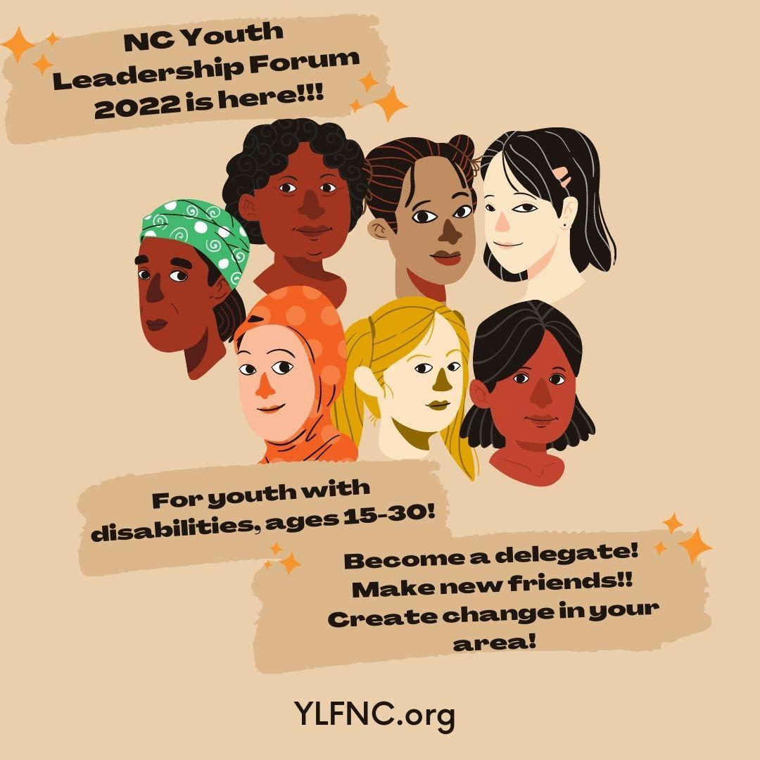

2022 NCYLF Delegate Application
Hosted by: Youth LEAD NC
Run by: Young people, ages 15 to 30, with disabilities
The 2022 North Carolina Youth Leadership Forum Committee would like to thank you for your interest in the virtual North Carolina Youth Leadership Forum (NCYLF). NCYLF is a five-day event full of self-discovery, learning, and fun! This event is free and provides accommodations upon request.
Topics will focus on advocacy, individual goals, leadership, independent living skills, and making change in the community. Small groups will give delegates the opportunity to get to know others with disabilities and who share similar experiences. Participants will also have the opportunity to participate in other fun activities throughout the program!
Interested in experiencing college life virtually? Please complete the following application and mail or email to the address below. If you have any questions, please feel free to contact us at ylfnc@live.com.
DEADLINE for postmark on mailed application: June 1st, 2022 at 5:00pm.
Mail or email the application to:
North Carolina Youth Leadership Forum
PO Box 90762
Raleigh, NC 27675
ylfnc@live.com
If mailing the application, please reach out to us via email so that we can keep an eye out for your application!
Dates & Times: July 18th-22nd; 9:30-3:30 pm with breaks for lunch and rest
Alternative Application forms will be available upon request!

Eligibility Criteria
- Have a disability
- Age 15-30
- Be a North Carolina Resident
- Interested in gaining leadership experience or have leadership experience
Are you NCYLF alumni?
- Yes, I attended ____ year.
- No, I am not.
Have you previously applied to NCYLF?
- Yes, I applied ___ year.
- No, I haven’t.
General Information:
Name : |  | Date of Birth: |  |  | Race/Ethnicity (optional):  Age:
Parent/Guardian Name (if under age 18): |  | Gender:
Address: |  |  | Preferred Contact Method:
Mailing Address (if different from above):

City: | Zip Code: |  |  | County:
Email Address:
Phone Number: |  | Fax Number:
Name of Current School/Workplace:
Other Educational Experiences:

High School: Dates:

Post High School: Dates: Course of Study:

Disability Information:
What is the name of your disability? Please include your diagnosis.
___________________________________________________________________________________________________________________________________
How long have you been a person with a disability? (Date):
Please check all that apply (continued on next page):

☐ MOBILITY DISABILITY
☐ Cerebral Palsy
☐ Juvenile Rheumatoid Arthritis
☐ Osteogenisis Imperfecta
☐ Multiple Sclerosis
☐ Muscular Dystrophy
☐ Spina Bifida
☐ Spinal Cord Injury
☐ Spinal Muscular Atrophy
☐ Other: ____________________
☐ I use a manual wheelchair
☐ I use a motorized scooter
☐ I use a power wheelchair
☐ I use a walker
☐ I use crutches
☐ Other:

☐ DEAF
☐ Culturally Deaf
☐ Deaf
☐ I use American Sign Language
☐ I use Lip Reading
☐ I use an Assistive Listening Device
☐ Other:

☐ HARD OF HEARING
☐ I use American Sign Language
☐ I use Lip Reading
☐ I use an Assistive Listening Device
☐ Other:

☐ LOW VISION
☐ I read with Braille
☐ I read with Large Print
☐ I use my PC/MAC Software to read
☐ Other:

☐ BLIND
☐ Legally Blind
☐ I read with Braille
☐ I read with Large Print
☐ I use my PC/MAC Software to read
☐ Other: __________

☐DEVELOPMENTAL DISABILITY
☐ Acquired Brain Injury
☐ Autism
☐ Down syndrome
☐ Epilepsy
☐ Traumatic Brain Injury
☐ Other:
☐ I use a daily assistant or a personal care assistant
☐ I use a facilitator
☐ I use a reader
☐ I use a writer
☐ Other:

☐ MENTAL HEALTH
☐ Anxiety
☐ Bipolar
☐ Depression
☐ Obsessive Compulsive Disorder
☐ Schizophrenia
☐ Other:

☐ LEARNING DISABILITY
☐ Attention Deficit Disorder
☐ Attention-Deficit Hyperactivity Disorder
☐ Dyslexia
☐ Visual Perception
☐ Other:
☐ I use a reader
☐ I use a writer
☐ I use specific PC/MAC Software

☐ IMMUNE DISABILITY
☐ Crohn’s Disease
☐ Grave’s Disease
☐ Lupus
☐ Multiple Sclerosis
☐ Psoriasis
☐ Rheumatoid Arthritis
☐ Other:

☐ CHRONIC ILLNESS
☐ Cancer
☐ Cystic Fibrosis
☐ Diabetes
☐ Endometriosis

☐ CHEMICAL ENVIRONMENTAL SENSITIVITY DISABILITY
Please describe:
☐ OTHER SPECIFIC DISABILITY

Please describe:

WEB ACCOMMODATIONS

Zooming with the NCYLF is committed to being a program that is accessible to all. Please answer all questions as they apply.

National Support Contact: This is someone who may be around the participant during the web series & wants to participate in our parent/natural support orientation.) ____________________________________________

Do you have access to reliable internet on a regular basis? If not, NCYLF will work with our partners for participants to still access activities.
___ Yes
____No
Do you have access to reliable transportation? NCYLF’s partners may have additional computers and technology at their offices.
___ Yes
___ No
Interpreters
___ American Sign Language ___Cued Speech ___Signed English
___Oral ___Communication Access Real-Time (CART)
___Other (please provide details):
_______________________________________________________________

Deaf/Blind Communication
Tactile Haptics Close Vision

Alternate Formats
__Braille ___Large Print ___Electronic

T-Shirt Size (NCYLF will mail your 2022 NCYLF T-shirt to the mailing address that you listed above.)
S ___ M___ L___XL ___XXL ___ XXXL ___Other____
Guardianship/Foster Care:

What is Guardianship? Guardianship is a legal relationship between an individual (the guardian) who has been given the legal authority and duty to make decisions on behalf of another individual.

Do you have a legal guardian? (Check one)
Yes ____ No_____ I don’t know _____

If yes, name of guardian and contact information:
Name: ______________________________________________________
Daytime #: _____________________ Nighttime #: ___________________
Email: ______________________________________________________
Address:_____________________________________________________

Are you currently in the foster care system? (Check one)
Yes ____ No____ I don’t know____

Please contact if any assistance is needed to complete the application by contacting NCYLF via email at ylfnc@live.com.

Short Answer Questions

- Why do you want to participate in Zooming with the NCYLF? What strengths can you bring to Zooming with the NCYLF?
- Describe how you feel about your disability. If you remember, how did you feel when you first learned you had a disability? How do you feel about your disability now?
- What are some of your future goals? How are you working to achieve them?
- Please enter all of your involvement with your school and/or community within the last five years.
High School: Colleges/Universities:
Clubs: After-school Activities:
Employment: Volunteering:
Faith Based Groups: Youth Group: Other:

Please make sure that you have responded to all the parts of the questions.
Any incomplete applications will not be considered for participation.

Participant Guidelines

If selected, the following are guidelines that are expected from each participant who attends the Zooming with the NCYLF web series. If you agree with the following guidelines, please sign below before submitting the application.

- Be respectful.
- Attend all webinars and small group hangouts unless there is notice of an excused absence communicated to your TA (peer mentor) at least 48 hours in advance.
- Actively participate on webinars, in small group hangouts, and during activities that are a part of the NCYLF web series.
- Do your best to stay for the entire webinar day unless you have notified your peer mentor.
- Communicate any accommodations, needs, or any difficulties with technology.
- HAVE FUN!!!
I hereby agree to these guidelines and will follow them to the best of my ability if I am selected as a participant for the Zooming with the NCYLF web series.

Electronic signatures are accepted.

Applicant Signature: _______________________________

Date: __________

Release for Healthy Relationship Discussion
(Only needed in case of under 18 years old)

I, legal guardian of (applicant name)_______________________am aware and have been informed that the NCYLF will be having a healthy relationship discussion. The topics that will be discussed are to educate and make the youth aware of risks that are related to relationships.

Please check one of the options found below:

_____ I approve of my youth participating in the healthy relationship discussion

_____ I do not approve of my youth participating in the healthy relationship discussion.

Applicant Initials: _____ Date ___________________

Parent/Legal Guardian Initials: _____ Date ___________________

North Carolina Youth Leadership Forum Media Release

CONSENT TO PHOTOGRAPH, FILM, OR VIDEOTAPE A PARTICIPANT FOR NON-PROFIT USE
(E.g. educational, public service, or health awareness purposes)

I hereby consent to the participation in interviews, the use of quotes, and the taking of photographs, movies or video tapes of the participant named above. I also grant the North Carolina Youth Leadership Forum the right to edit, use, and reuse said products for nonprofit purposes including use in print, on the internet, and all other forms of media. I also hereby release the North Carolina Youth Leadership Forum, members, mentors, and affiliated organizations from all claims, demands, and liabilities whatsoever in connection with the above.

Applicant Initials: _____ Date ___________________

Parent/Legal Guardian Initials: _____ Date ___________________

Thank you for your interest in the NCYLF! We will notify you soon of your application status!!

